USE CASE Diagram
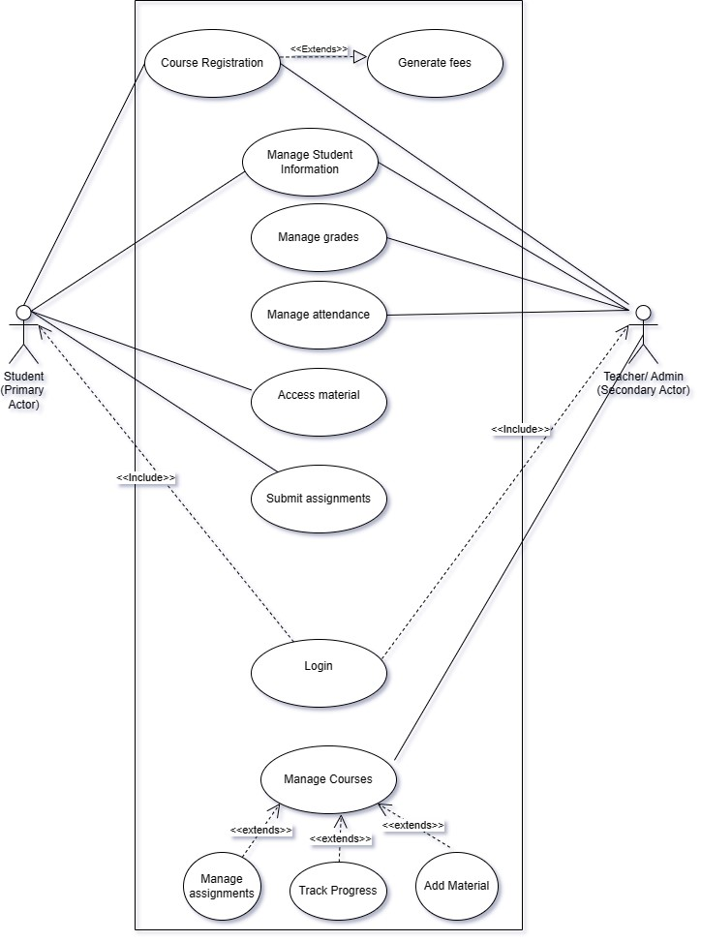
Software Requirement Specifications

[Ilm Ghar]

Version: [1.0]

Project Code | FSE-IG
Supervisor | Miss Sania Urooj
Project Team | Arham Hussain Khan 22K-4080  Aarib Ahmed Vahidy 22K-4004  Partham Kumar Chawla 22K-4079
Submission Date | 17 March 2024

[Instructions]
- No section of template should be deleted. You can write ‘Not applicable’ if a section is not applicable to your project. But all sections must exist in the final document.
- All comments/examples mentioned in square brackets ([]) are in the template for explanation purposes and must be replaced / removed in final document.
- This’ Instruction’ section should also be removed in final document.

NOT APPLICABLE

Document History
Version | Name of Person | Date | Description of change
1.0 | Aarib Ahmed Vahidy | 14 March 2024 | Document Created
1.1 | Aarib Ahmed Vahidy | 15 March 2024 | Added Functional Requirements
1.2 | Aarib Ahmed Vahidy | 15 March 2024 | Fixed Font Errors
1.3 | Aarib Ahmed Vahidy | 16 March 2024 | Added Non Functional Requirements and completed the document.

Document Sign-Off

Version | Sign-off Authority | Sign-off Date
1.2 | Partham Kumar Chawla | 15 March 2024
1.3 | Arham Hussain Khan | 16 March 2024

Table of Contents

1. Introduction 7
1.1. Purpose of Document 7
1.2. Intended Audience 7
1.3 Abbreviations ………………………………………………………………………………………...7
1.4. Document Convention 7
2. Overall System Description 8
2.1. Project Background 8
2.2. Project Scope 8
2.3. Not In Scope 8
2.4. Project Objectives 8
2.5. Stakeholders 8
2.6. Operating Environment 8
2.7. System Constraints 8
2.8. Assumptions & Dependencies 8
3. External Interface Requirements 9
3.1. Hardware Interfaces 9
3.2. Software Interfaces 9
3.3. Communications Interfaces 9
4. Functional Requirements 10
4.1. Functional Hierarchy 10
4.2. Use Cases 10
4.2.1. [Title of use case] 10
5. Non-functional Requirements 11
5.1. Performance Requirements 11
5.2. Safety Requirements 11
5.3. Security Requirements 11
5.4. User Documentation 11
6. References 12
7. Appendices 13

- Introduction

  - Purpose of Document
This document outlines the software requirements for Ilm Ghar - an Online Teaching Platform.
  - Intended Audience
This document is intended for the project team, stakeholders, developers, and anyone involved in the development or use of the Ilm Ghar platform.
1.3 Abbreviations
NOT APPLICABLE
  - Document Convention
Font :- Arial
Font Size :- 12

- Overall System Description
  - Project Background
Ilm Ghar aims to revolutionize education in Pakistan by providing a user-friendly online teaching platform.
  - Project Scope
The project aims to develop an online teaching platform encompassing frontend and backend systems to deliver a seamless learning experience.
  - Not In Scope
Hardware procurement and physical infrastructure setup are not within the scope of this project.
  - Project Objectives
To develop a user-friendly online teaching platform catering to Pakistani students' educational needs.
  - Stakeholders
Stakeholders include students, educators, administrators, and technical support personnel.
  - Operating Environment
The platform will operate on web browsers across various devices including desktops, laptops, and mobile devices.
  - System Constraints
Software constraints: Compatibility with modern web browsers.
- Hardware constraints: None identified.
- Cultural constraints: Language support for Urdu and English.
- Legal constraints: Compliance with data protection regulations.
  - Assumptions & Dependencies
Assumption: Availability of stable internet connections for users.
Dependency: Integration with payment gateways for enrollment.

- External Interface Requirements
Hardware Interfaces
N/A

Software Interfaces
- Integration with payment gateways for transactions.
- Integration with messaging services for communication.

Communications Interfaces
- HTTP/HTTPS protocols for web communication.
- Email notifications for user interactions.
- Functional Requirements
  - Functional Hierarchy
- User Authentication
- Login
- Registration
- Course Management
- Course Enrollment
- Content Delivery
- Communication
- Messaging
  - Use Cases

DONE IN USE CASE DIAGRAM.

<Use case Id: name>
Use case Id: |  | 1.1
Actors: <List of actors (external agents), indicating who initiated the use case>
Feature: <Feature from which the use case is driven>
Pre-condition: |  | <List the assumptions required before this Use Case can be executed. >
Scenarios
Step# | Action |  |  | Software Reaction
1. | Numbered actions of the actors |  |  | Numbered description of system responses
2.
Alternate Scenarios: Write additional, optional, branching or iterative steps. Refer to specific action number to ensure understandability.
1a:

2a:

Post Conditions
Step# | Description
 | Sequentially list conditions expected at the completion of the use case.
Use Case Cross referenced |  |  | <Related use cases, which use or are used by this use case>

- Non-functional Requirements
  - Performance Requirements
Page load time: Maximum 3 seconds.
Concurrent user handling: Minimum 1000 users.

  - Safety Requirements
Data encryption for user information.
Regular data backups.

  - Security Requirements
Secure user authentication mechanism.
Protection against SQL injection attacks.

  - User Documentation
User Manuals
Online help

- References
NOT APPLICABLE

- Appendices
NOT APPLICABLE

